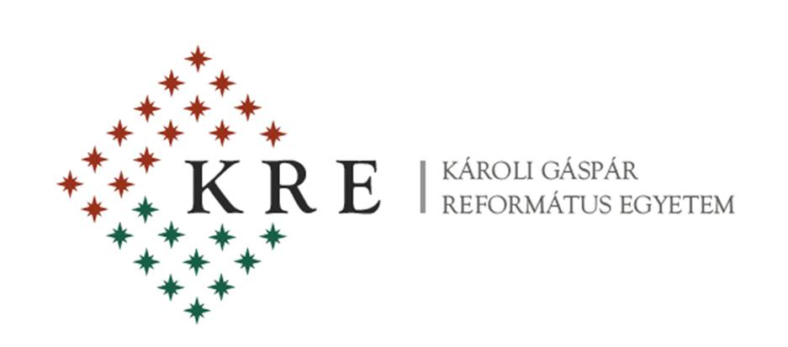

The Department of English Language and Literature &
The Department of Modern Languages
of Partium Christian University, Oradea (Romania)

in cooperation with

Károli Gáspár University of the Reformed Church, Budapest (Hungary)

are pleased to announce the 5th

EL&LE

INTERNATIONAL CONFERENCE
on
English Language & Literatures in English
to be held on
4-5 September 2015

The conference committee welcomes original contributions on such topics as follows:

- American Literature
- British Literature
- Canadian Studies
- Central Europe and the English-Speaking World
- Cultural Studies
- ESP
- Ethnic Studies
- Gender Studies
- Intermediality
- Language Studies
- Literary Theory and Criticism
- Literatures in the English Language
- Multilingualism and Multiculturalism
- Philosophy
- Postcolonial Studies
- Religious Studies
- Translation Studies

Deadline for Submission of Proposals: 1 July 2015

Those who wish to present a paper are kindly asked to fill in the registration form below and send it to timea.ardelean@gmail.com .

REGISTRATION FORM
First name:
Surname:
Affiliation:
Title of paper:
Abstract (100-150 words):
Key-words (4 or 5):
Minibio/CV (5 or 6 lines)

Conference fee:
Participants from Romania: 200 RON
Participants from abroad: 50 EURO

The fee will be paid upon arrival. The fee covers participation costs, coffee breaks, cocktail on the 4th (Friday), lunch and closing dinner on the 5th (Saturday), conference program, online publication of papers in The Roundtable, the Partium Journal of English Studies, (http://www.theroundtable.ro/). A selection of conference papers will be published in print.

Accommodation:

PC University Hostel: 10 EUR/night, in double or triple bedded rooms; shared bathroom.
Atrium Hotel [www.hotelatrium.ro] – a ten minute walk from the railway station.
Ramada Hotel [www.ramada.com/hotels/romania/oradea] – a ten minute walk from the Partium University.
Nevis Hotel [http://www.hotelnevis.ro/]

Conference Venue: The conference will take place in the university main building (27 Primăriei Street).

Oradea can be reached:

by train – from Bucharest (via Cluj-Napoca); from Timișoara (via Arad); from Budapest (Hungary).

Getting to the university:

Take a cab from across the railway station. We recommend the HELLO, FULGER, CITY or START companies. If you feel like walking, follow the tram line past the CRIȘUL hypermarket on your right, make a right, and cross the bridge. From the City Hall turn right and in about five minutes you will reach the university main building on your right.

Address: Strada Primăriei 27, Oradea, Romania
GPS coordinates: Latitude: 47.056845 Longitude: 21.922328

We look forward to meeting you in Oradea in September.

