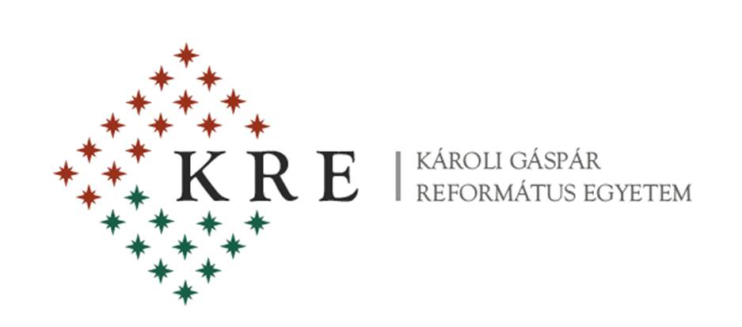

The Departments of
English Language and Literature & Modern Languages
of Partium Christian University, Oradea (Romania)

in cooperation with

Károli Gáspár University of the Reformed Church, Budapest (Hungary)

are pleased to announce the 6th

EL&LE

INTERNATIONAL CONFERENCE
on
English Language & Literatures in English
to be held on
8 April 2016

The conference committee welcomes original contributions on such topics as follows:

- American Literature
- British Literature
- Canadian Studies
- Central Europe and the English-Speaking World
- Cultural Studies
- ESP
- Ethnic Studies
- Gender Studies
- Intermediality
- Language Studies
- Literary Theory and Criticism
- Literatures in the English Language
- Multilingualism and Multiculturalism
- Philosophy
- Postcolonial Studies
- Religious Studies
- Translation Studies
M.A. students are also invited to make presentations in sessions for postgraduate students.

Deadline for Submission of Proposals: 1 February 2016

Those who wish to present a paper are kindly asked to register on: https://partiumenglish.wordpress.com/

Conference fee:
 | Early-bird Registration  Until 10 March | Late Registration  After 11 March
Participants from Romania | 200 RON | 250 RON
students | 100 RON | 150 RON
Participants from abroad | 50 Euros | 70 Euros
Students from abroad | 25 Euros | 40 Euros

The fee covers participation costs, conference paper folder, conference program, coffee breaks, lunch and closing dinner on 8 April. A selection of conference papers will be published in print.

Method of payment
By bank transfer.
SWIFT Code OTPVROBU
Account number:
RO88 OTPV 22 0000 290 701 RO03 (lei)
RO48 OTPV 22 1000 290 701 EU 01 (euros)
Please, indicate the following payment purpose on the bank transfer order: EL&LE Conference. Bank transfer charges have to be paid by the registrant.
Requests for invoice must be indicated by email to the Organizers, at partium.english@gmail.com

Refund policy:
All cancellation must be notified by email to the Organizers, at partium.english@gmail.com
- Before 15 March, 2016: 50 % of registration fee will be refunded
- After 15 March, 2016: no refund

Reimbursment will be processed after the conference.

